My account

SWIM Registry Usage Scenarios

Overview
This usage scenario covers view and edit account information

UC001: Access and view account information

Precondition
Logged in

User Interaction
The user needs to execute the following actions.

Access My account
The user needs to :
- Go to registry home page http://dev.eur-registry.swim.aero/, log in and follow the link My Account.

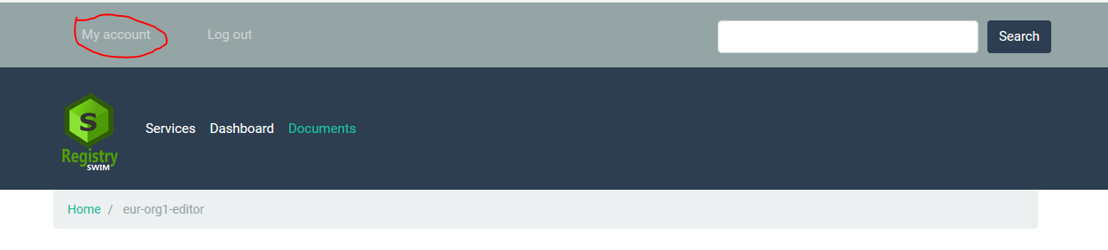

view my account
The following account information should be available:
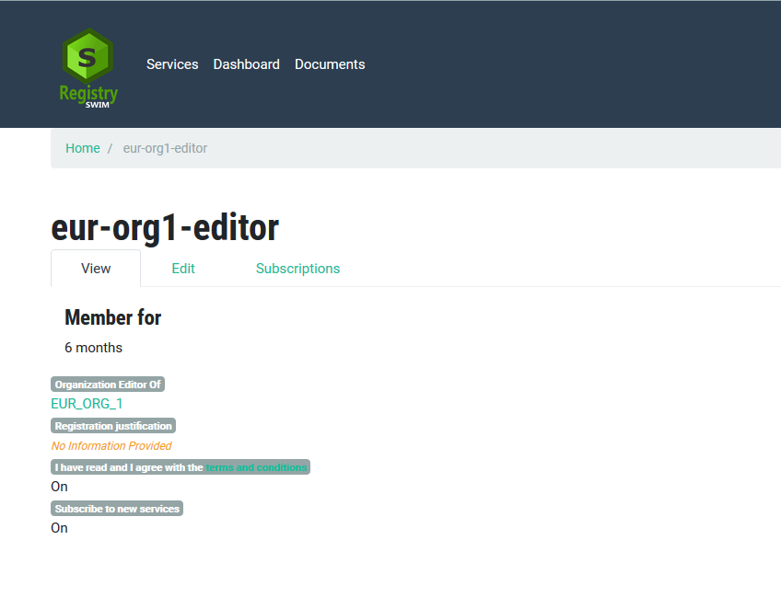

UC002: edit account informaiton

Precondition
Logged in

User Interaction
The user needs to execute the following actions.

edit My account
The user needs to :
- Go to My Account and follow the link Edit:
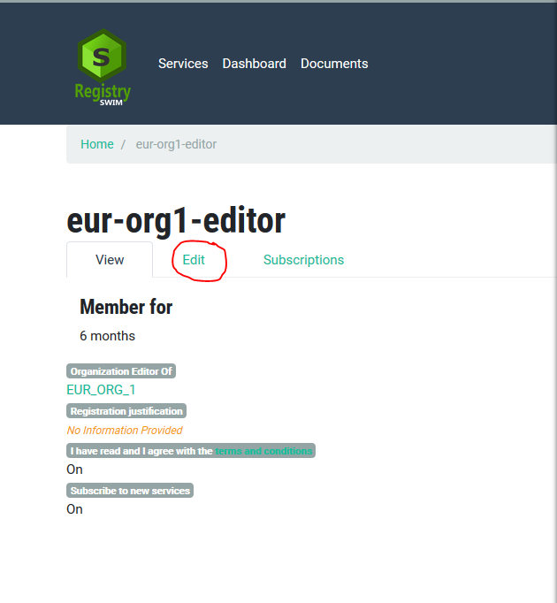
Provide changes where necessary and click Save when done.
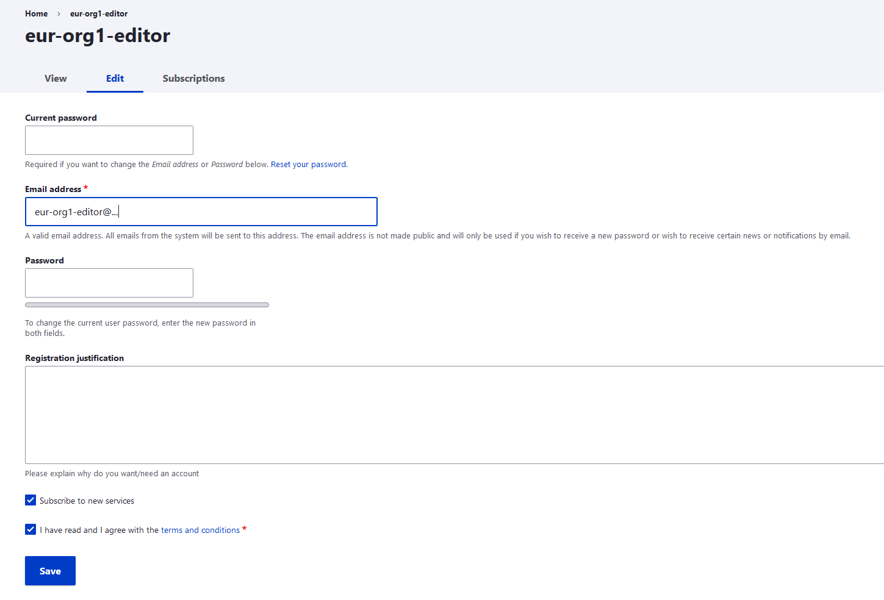

UC003: manage subscripitions

Precondition
Logged in

User Interaction
The user needs to execute the following actions.

Manage subscriptions:
Go to My Account as explained early and follow the link Subscriptions:
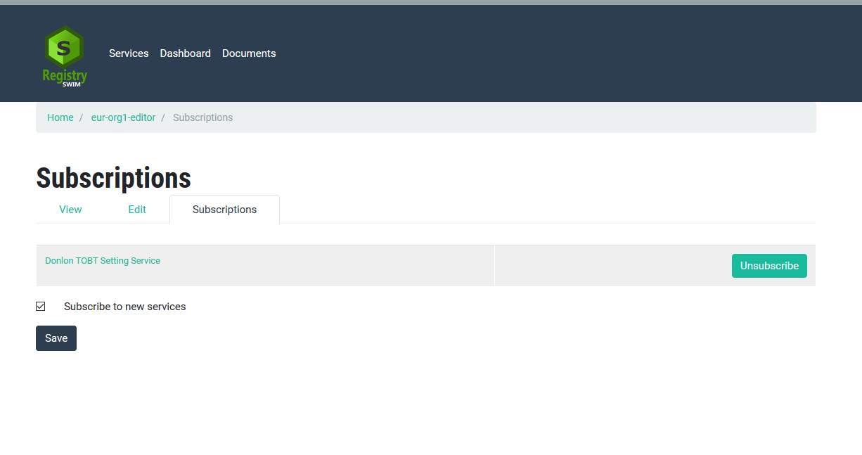
User can choose to Subscribe or Unsubscribe to a specific service or Subscribe to new services. Click Save when done.

