Register and edit a service

SWIM Registry Usage Scenarios

Overview
This usage scenario explains how to register and edit a service of your organisation

UC001: Register a new service

Precondition
Logged in
Being the Organisational Editor of your organisation
Your organisation is registered

Outcome
Please contact Registry Administrator if you do not have the right role or your organisation is not registered

User Interaction
The organisational editor needs to execute the following actions.

Register a new service
The editor needs to:
- Go to Services and following the link Add Service:
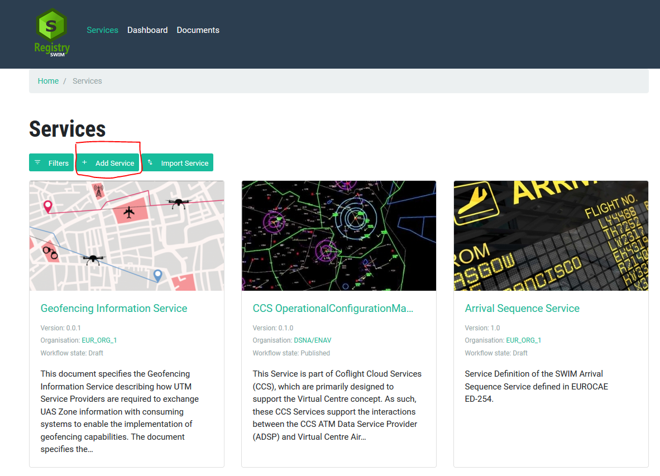

Provide the required information
The editor needs to provide all required information:
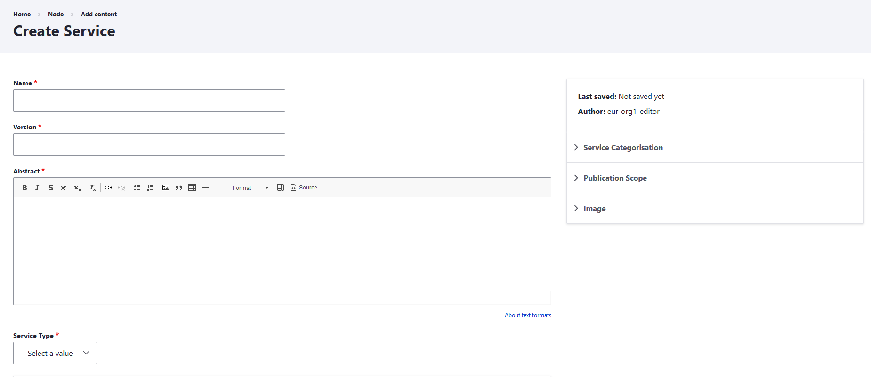
NOTE: please collapse all filed on the right hand side related to Service Categorisation, Publication and Image.
Under Publication Scope the editor can choose the level of restriction:
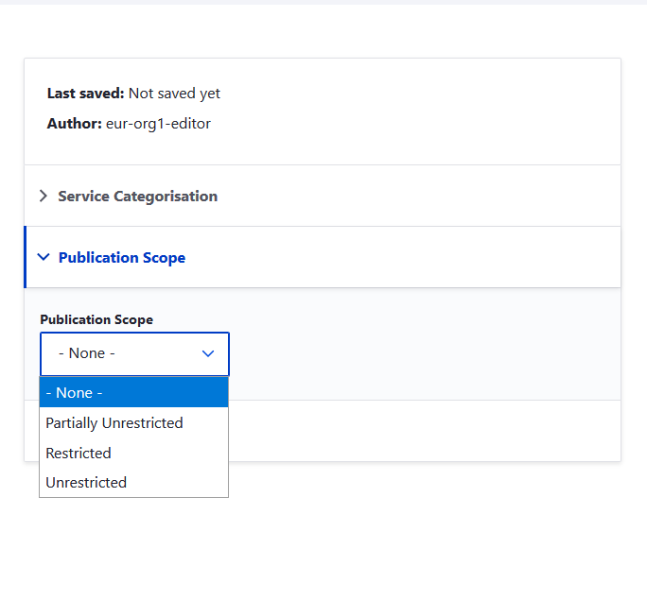
Unrestricted: All information will be visible to unauthenticated user on the homepage (i.e. without log in).
Partially Unrestricted: Contact details will be hidden from the unauthenticated user, but other information about the service will be visible on the homepage.
Restricted: All information about the service will only be visible to authenticated user

More detailed information can be provided under each service attribute:
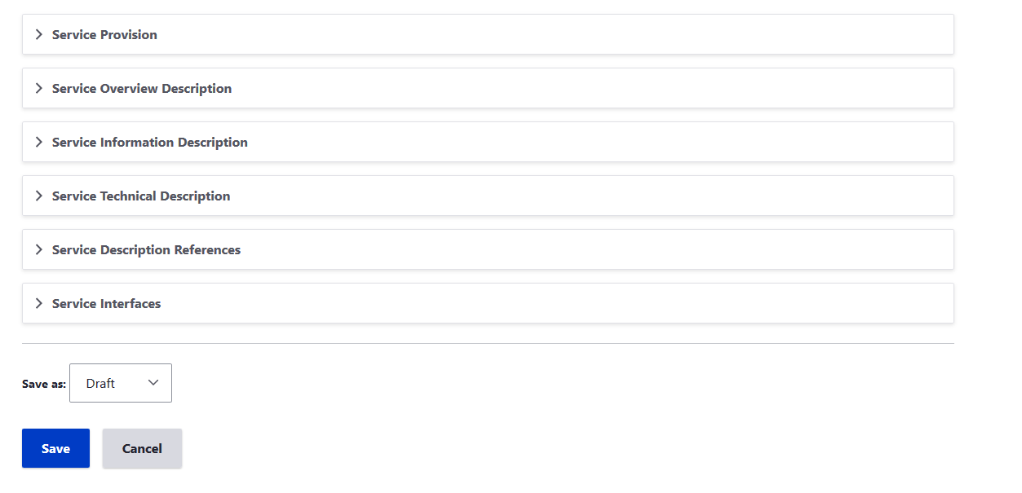

Please collapse each of the Service attribute to provide the required information. Click Save when done.

UC002: service validation

Precondition
Service attributes are filled in and user considers the information is sufficient to move to Validation

Outcome
- All required service information are completed – Service changes from Draft to Validation
- Missing required service information – Service remains being Draft and an error notification will be shown

User Interaction
The editor needs to execute the following actions.

Transition to validaiton
The editor needs to:
- Completed the required fields in different service attributes as described in the UC001 and click Validation:
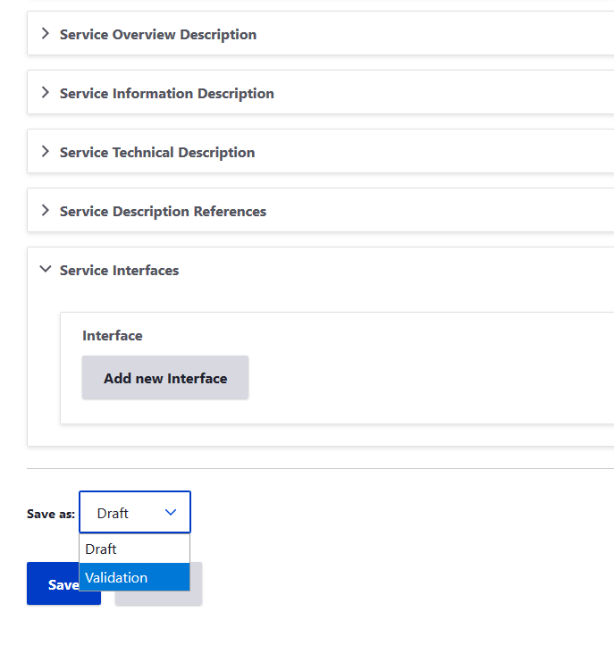

When successful, the service will enter the phase Validation.
When failed, an error notification will be shown in red:
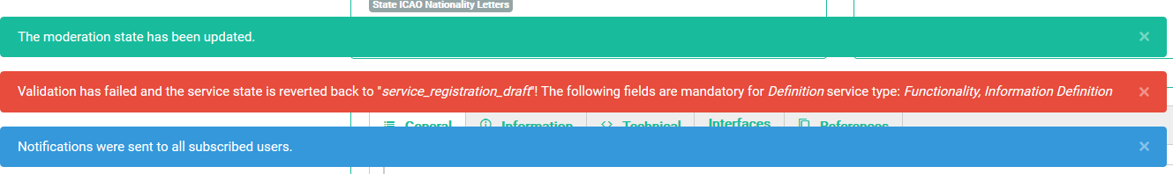

UC003: edit a registered service

Precondition
Being the Organisational Editor of your organisation
Your organisation is registered
You have registered at least one service

Outcome
- Service information can be modified
- Workflow can be modified

User Interaction
The user needs to execute the following actions.

Edit service information
Go to the service and click the ‘pen’ icon:
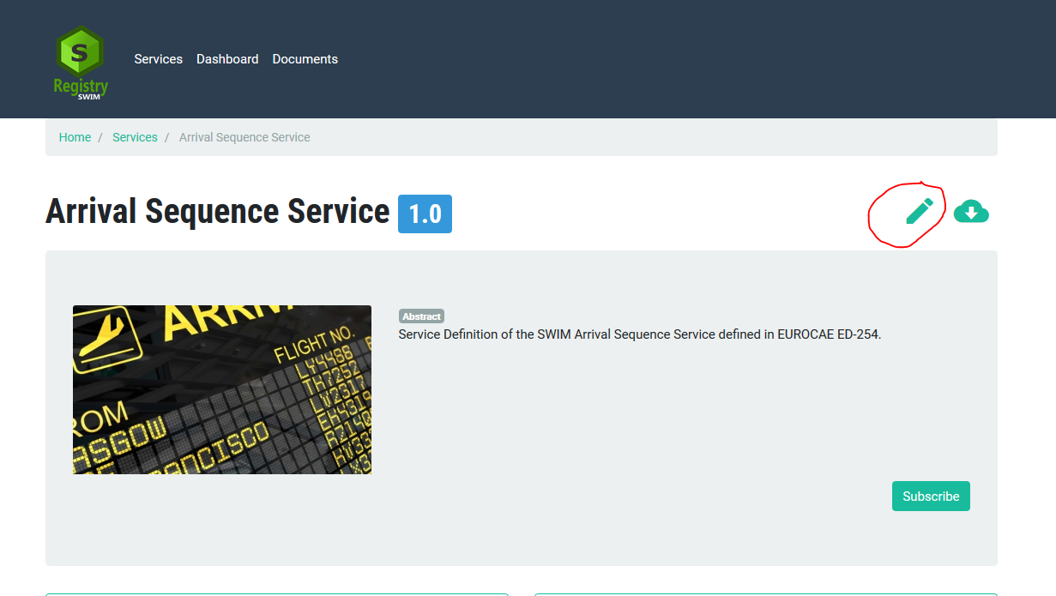

Edit all fields that require modification:
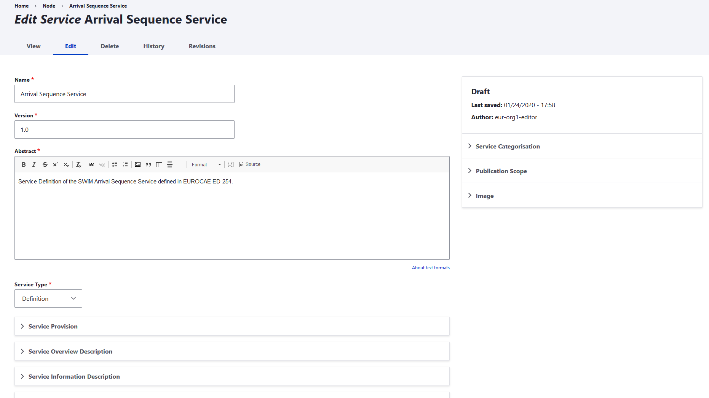
Change the state of the service: Draft Validation

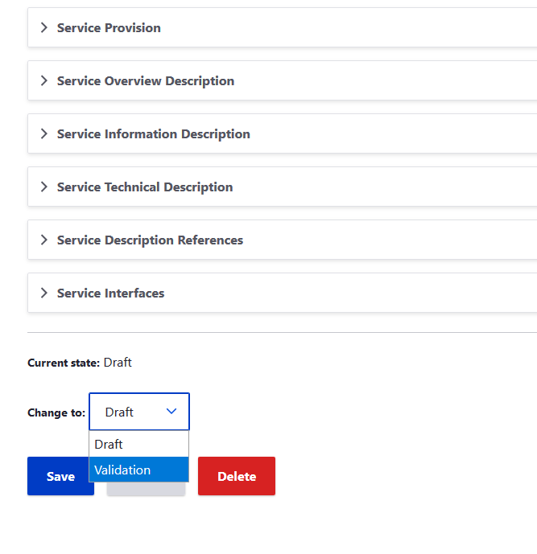
Click Save when done.
Service can also be Deleted when needed!

View current state and workflow
The current state of the service, workflow and Registration history can be seen at the bottom of the service page.
